**Basic game description:**

Try and fit your schedule in the box as best you can while managing your stress, grades, and more.

**What you are trying to teach to the incoming freshman:**

The idea of balancing all the things you need while not burning yourself out (And that you don’t have time for everything)

Work/life balance and mental management

**How gameplay mechanics implement facets of Bloom's Taxonomy:**

I feel this goes into apply and analyze. You have to take what you know about time management and also how it will affect what you do

**How gameplay mechanics implement 1 (or more) pedagogical approaches:**

This could possibly be liberationism, the player has full control with the only limits being what blocks they have and any potential lock. They choose how to go about it however.

**Is there any information that you are assuming the student already has (within reason, we can assume they know what "homework" is, etc.)**

I assume they react to certain things in a fairly typical way (homework/classwork causing stress) (more sleep improving mood) (cooking at home saves money)

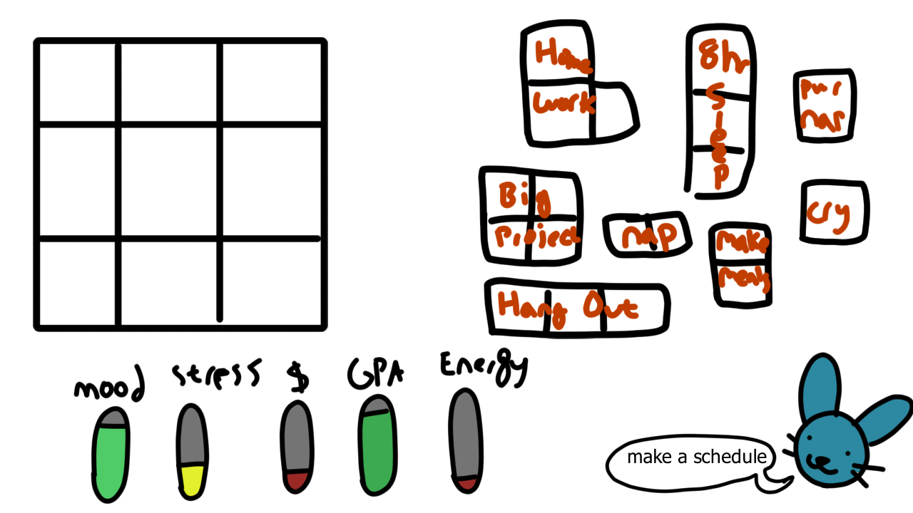

Game lasts however many weeks a semester is

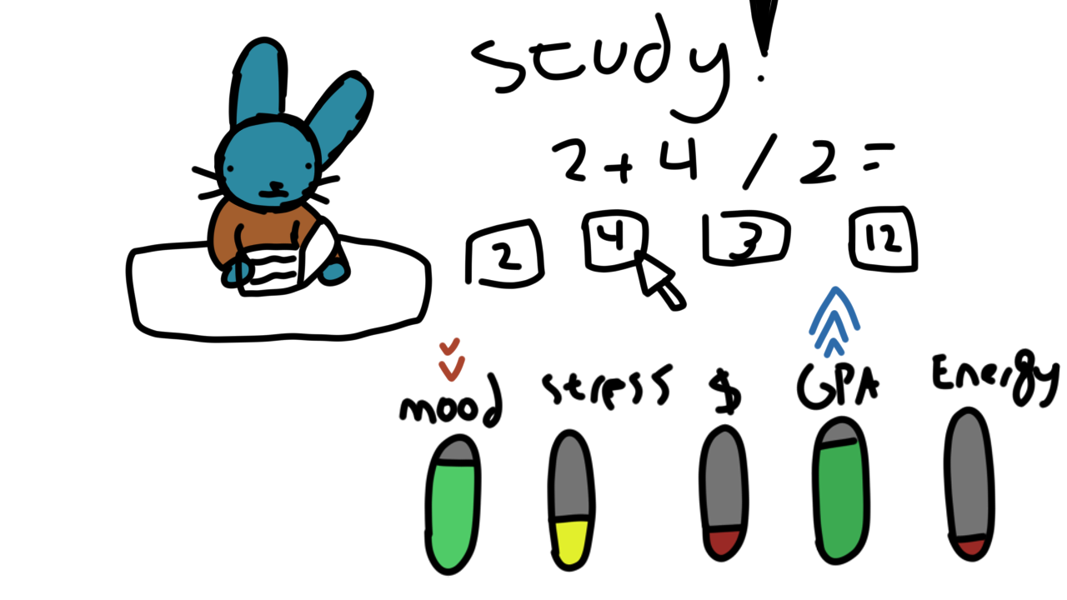

Little minigames for the choices (just to break up the gameplay a bit)

Doing better in the minigame boosts up stats and reduces down stats

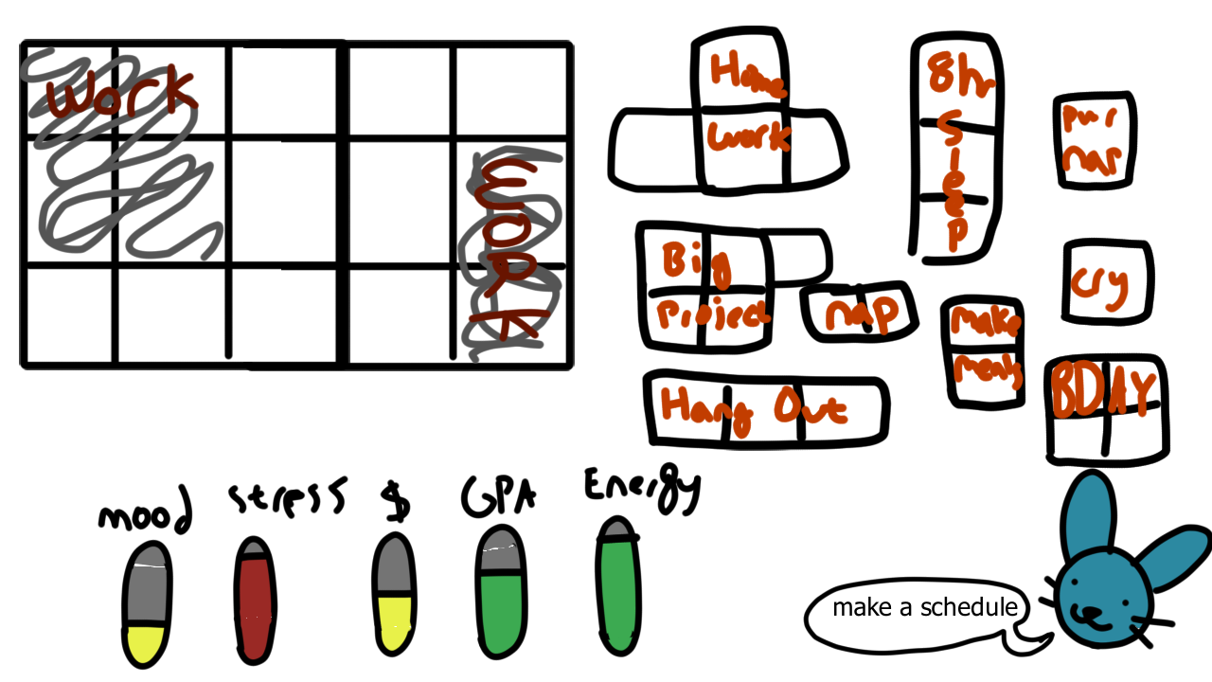

Sometimes you have blocks filled due to other options

If you put off certain things, they’ll become larger

Having more energy gives more room

Certain things are only at a time (BDAY) and might have penalties for missing (huge mood down)

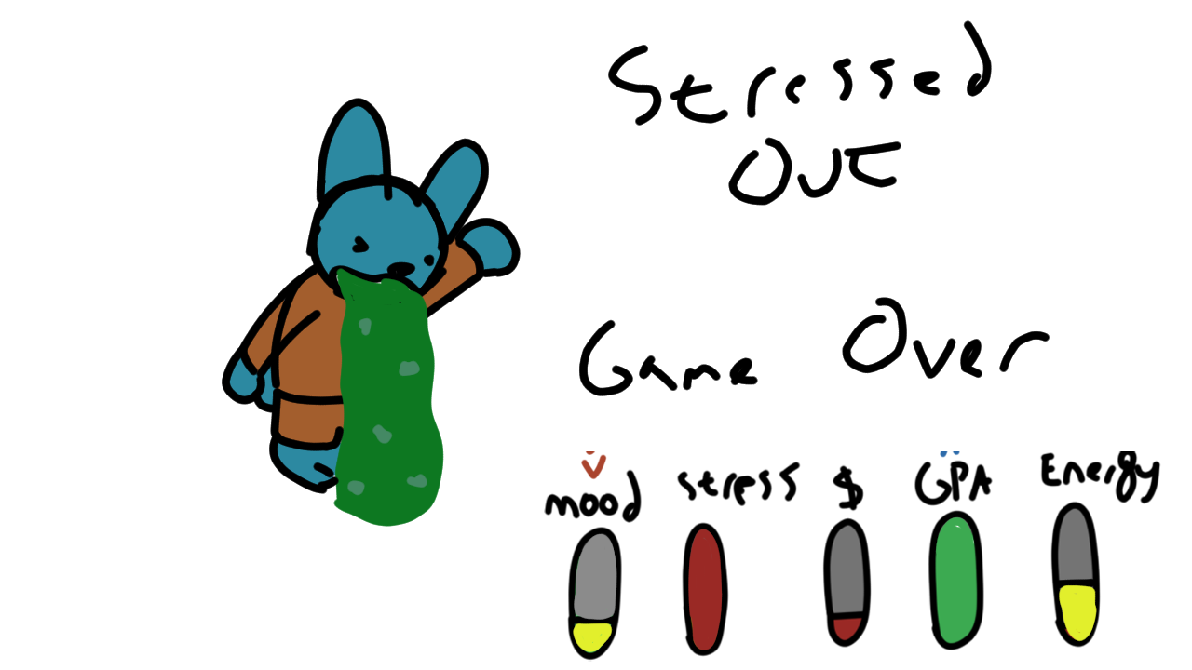

Gameover states for not taking care of all the things